PCPOINT
ONLINE COMPUTER & HARDWARE MARKETPLACE

WEEK 01 REPORT

Project: PcPoint E-Commerce Website | Week: Week 01
Student Reg_No: TG/2024/2122___________________ | Date: ________16/08/2026____________

1. Introduction
This report covers the Week 01 deliverables for PcPoint, an e-commerce website being developed for an online computer and hardware store. The purpose of this week's work was to move from a raw idea to a clear, documented plan before any coding began: defining the business itself, analysing what the system needs to do, and outlining the technical architecture that will support it.
The planning process included studying existing local computer and hardware e-commerce stores (Nanotek, Chama Computers, SellX, and Redline Technologies) as references, identifying PcPoint's target customers and product range, listing the core features and pages the website needs, mapping the customer's user flow, and choosing the MERN (MongoDB, Express.js, React.js, Node.js) stack as the technology foundation for development.
This report is structured into four main sections: Business Description, Requirement Analysis, System Architecture, and a Development Log with supporting evidence (screenshots) from Day 1 of the planning process.

2. Business Description

2.1 What is PcPoint?
PcPoint is an online computer and hardware marketplace based in Sri Lanka. It is an e-commerce platform where customers can browse and purchase laptops, desktop computers, custom-built gaming PCs, computer components, and accessories, with the convenience of islandwide delivery. The goal of PcPoint is to bring together quality hardware, competitive pricing, and reliable after-sales support under one easy-to-use online store — similar in concept to existing local players such as Nanotek, Chama Computers, SellX, and Redline Technologies.

2.2 Who Are the Customers?
- Gamers and PC enthusiasts looking for custom-built gaming PCs and high-performance parts
- Students who need affordable, reliable laptops for study
- Working professionals and freelancers who need laptops or desktops for work
- Small businesses and offices purchasing IT equipment in bulk
- Content creators / designers needing higher-spec workstations
- General customers looking for computer accessories and peripherals

2.3 What Can Customers Buy?
- Laptops (budget, business, and gaming laptops)
- Desktop PCs and pre-built / custom gaming PCs
- PC components — processors, motherboards, RAM, storage (SSD/HDD), graphics cards, power supplies, casings
- Monitors and displays
- Peripherals & accessories — keyboards, mice, headsets, speakers, webcams
- Networking equipment — routers, switches, cables
- Printers, scanners, and other office IT equipment

2.4 What Can Customers Do on the Website?
- Browse and search products by category, brand, or price range
- View detailed product pages with specifications, images, and price
- Compare different products before buying
- Add products to a cart and complete secure checkout
- Create an account, log in, and view order history
- Track the status of an order/delivery
- Read and leave product reviews and ratings
- Build a custom PC and generate a PDF price quotation
- Contact customer support and request warranty / after-sales service

3. Requirement Analysis

3.1 Functional Requirements
- Users can register, log in, and log out securely (JWT-based authentication)
- Users can browse products by category, and filter/sort by price, brand, or popularity
- Users can search for a product by keyword
- Users can view a product's full details, specifications, images, and stock status
- Users can add products to a cart, update quantities, and remove items
- Users can check out, enter shipping details, and select a payment method
- Users can view past orders and track the current status of an order
- Users can leave a rating and review on a purchased product
- Users can build a custom PC by selecting parts (CPU, motherboard, RAM, GPU, storage, PSU, case, cooling, monitor, keyboard/mouse) and generate a downloadable PDF quotation
- Admin can add, edit, or remove products, categories, and PC-build parts
- Admin can view and update the status of customer orders
- Admin can view stock levels and update inventory

3.2 Non-Functional Requirements
- Usability — the interface should be simple and intuitive for non-technical customers
- Performance — product and category pages should load quickly even with many products
- Security — passwords must be hashed, and sensitive routes protected with authentication/authorization
- Scalability — the database and API design should support a growing product catalogue and user base
- Availability — the website should be accessible with minimal downtime, since customers may order at any time
- Responsiveness — the site must work well on both desktop and mobile screens
- Maintainability — code should be organised into clear modules (models, routes, controllers, components) to make future changes easier

3.3 Technology Stack (MERN)
The website will be built using the MERN stack, which was selected for its flexibility, single-language (JavaScript) development across frontend and backend, and strong community support for building scalable e-commerce applications.
- MongoDB — NoSQL database to store product, user, order, and cart data
- Express.js — Backend web framework to build REST APIs (products, auth, orders, payments)
- React.js — Frontend library to build the customer-facing store and admin dashboard UI
- Node.js — JavaScript runtime powering the backend server
Planned additional tools: JWT for authentication, Mongoose for MongoDB schema modeling, Tailwind CSS / Bootstrap for styling, jsPDF for generating build quotations, and a payment gateway integration (e.g. PayHere) for local transactions.

4. System Architecture

4.1 Architecture Overview
PcPoint follows a three-tier client–server architecture typical of MERN applications. The React.js frontend (client) communicates with an Express.js/Node.js backend over a REST API using JSON and HTTP requests. The backend handles business logic, authentication, and validation, then reads from and writes to a MongoDB database. A third-party payment gateway is integrated at the backend for processing online payments.

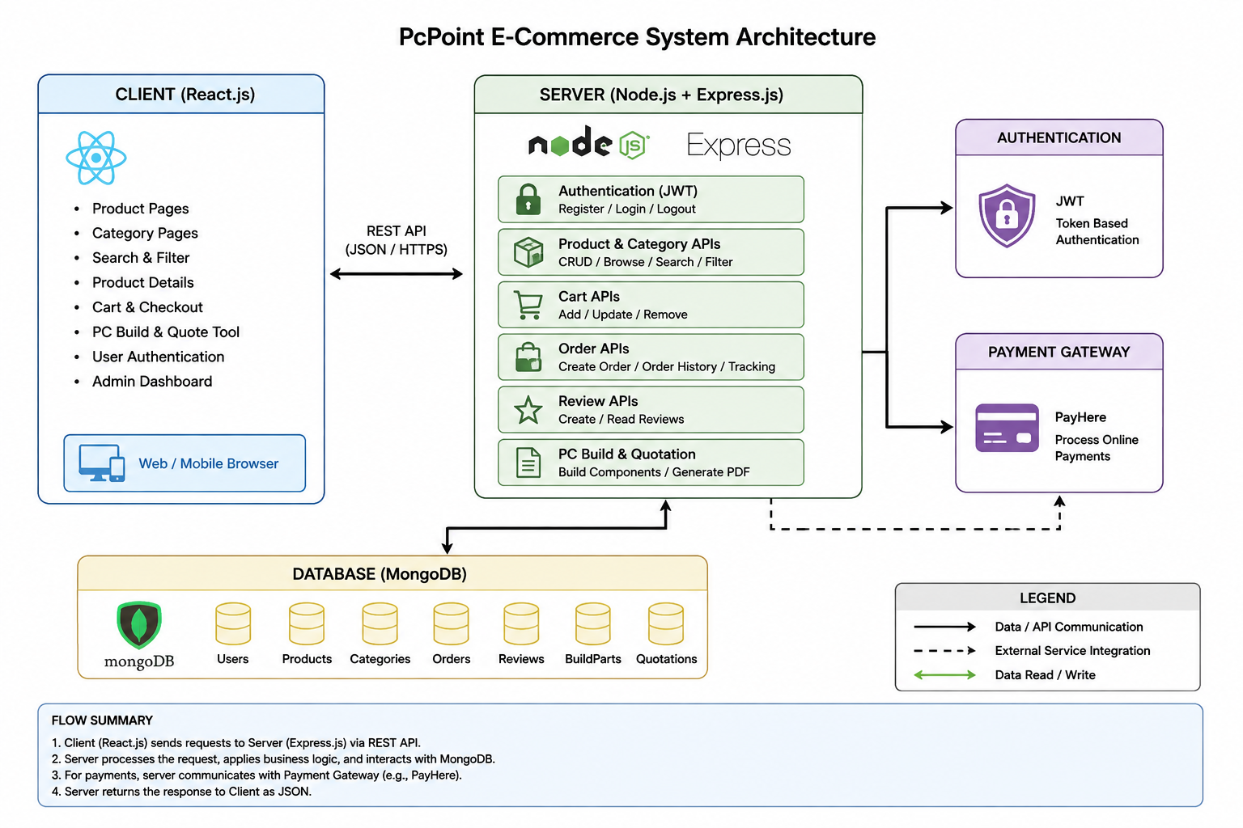
4.2 Architecture Diagram

4.3 Component Description
- Client (React.js): renders the UI, manages cart/auth state, and calls the backend REST API via Axios
- Server (Node.js + Express.js): exposes REST endpoints for authentication, products, categories, orders, reviews, and PC-build quotations; contains all business logic and validation
- Database (MongoDB): stores Users, Products, Categories, Orders, Reviews, BuildParts, and Quotations as documents, accessed through Mongoose models
- Authentication: JSON Web Tokens (JWT) issued on login, verified via middleware to protect user and admin routes
- Payment Gateway: external service (e.g. PayHere) integrated at the backend to process online payments for checkout
- PDF Generation: jsPDF (client-side) or a server-side PDF library used to generate branded quotation documents from the PC Build tool

Development Log & Evidence
On Day 1 of development, the focus was on defining the core concept of the website: what the business is, who it serves, what it sells, and what functionality the website must provide. This was done by studying similar existing online computer and hardware stores in Sri Lanka as reference points.

Reference Websites Studied
The following existing Sri Lankan computer/hardware e-commerce websites were studied as references for structure, product categories, and features:
Nanotek | https://www.nanotek.lk/
Chama Computers | https://www.chamacomputers.lk/
SellX | https://sellx.lk/
Redline Technologies | https://www.redlinetech.lk/

Evidence — Day 1 Screenshots


Screenshot 1 — Nanotek.lk Homepage
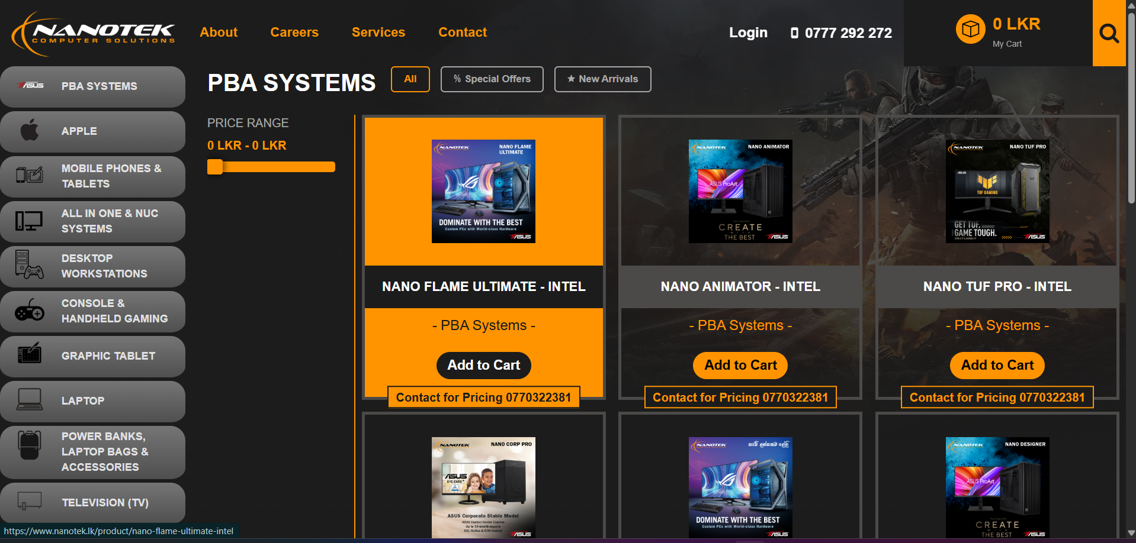
Screenshot 2 — Nanotek.lk (Gaming PC) Category
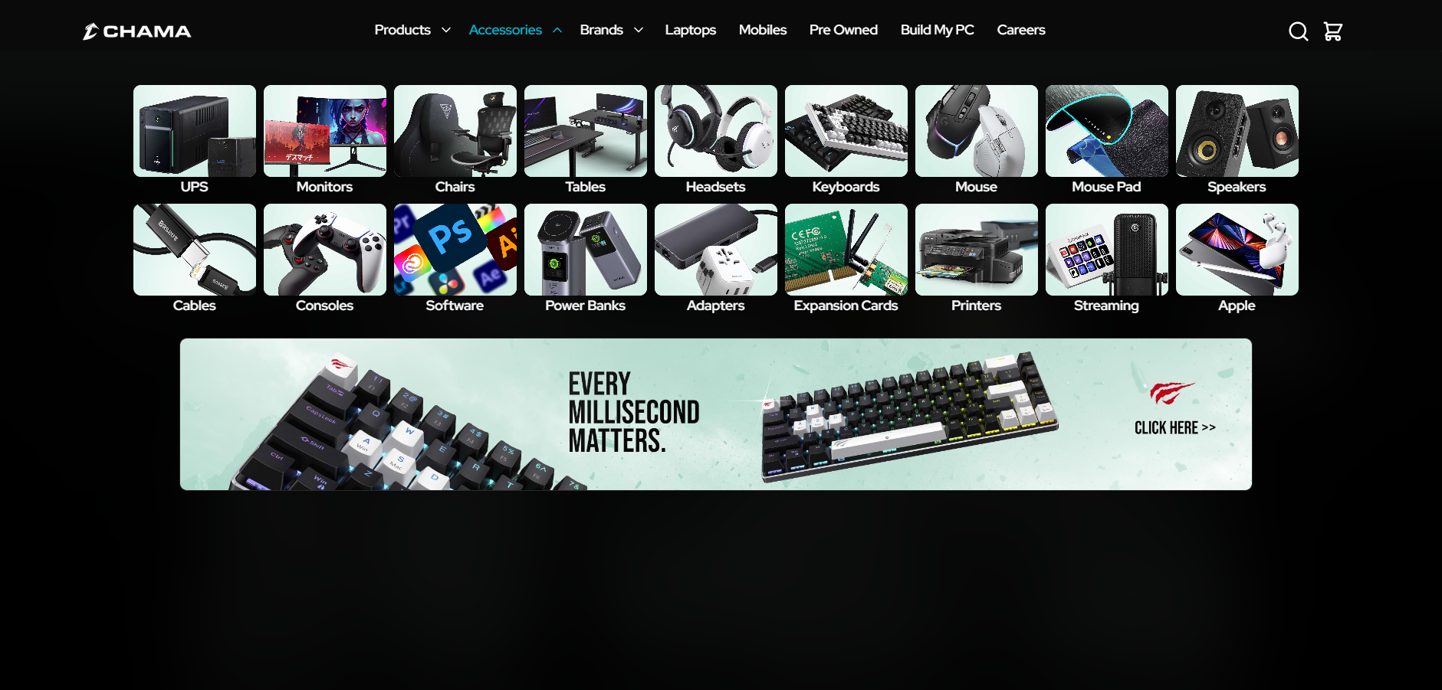
Screenshot 3 — ChamaComputers.lk Accessories Category
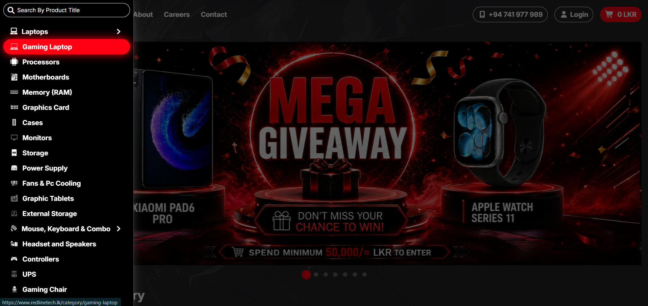
Screenshot 4 — RedlineTech.lk Category Page
PCPOINT
ONLINE COMPUTER & HARDWARE MARKETPLACE

WEEK 02 REPORT

Project: PcPoint E-Commerce Website | Week: Week 02
Student Name: __TG/2024/2122  A.A Eshan__________________ | Date: __23/08/2026__________________

This report covers the Week 02 deliverables for PcPoint: wireframing and system architecture planning. This document presents the wireframes for key pages, the Entity Relationship (ER) Diagram, the full list of database tables/collections with their attributes, and evidence of the GitHub repository set up for version control.

1. Wireframing Key Pages
Low-fidelity, black-and-white wireframes were created to map out the layout and information hierarchy of PcPoint's key pages before any visual design or coding began. Screenshots of each wireframe are provided below as evidence.This Wireframes designed using adobi Photoshop.
HOME page

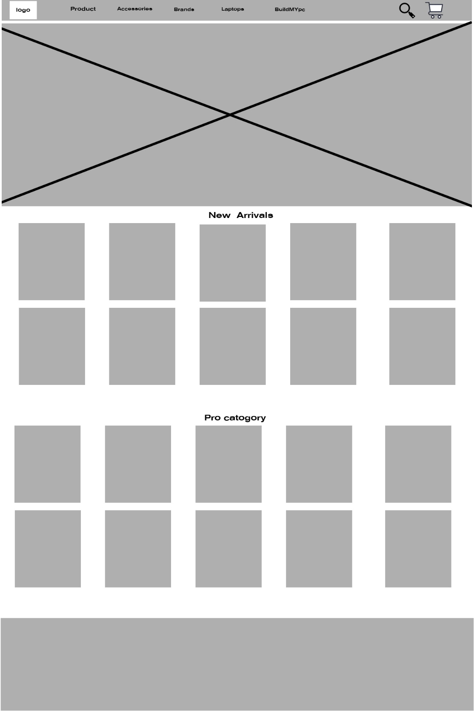

Product Listing Page
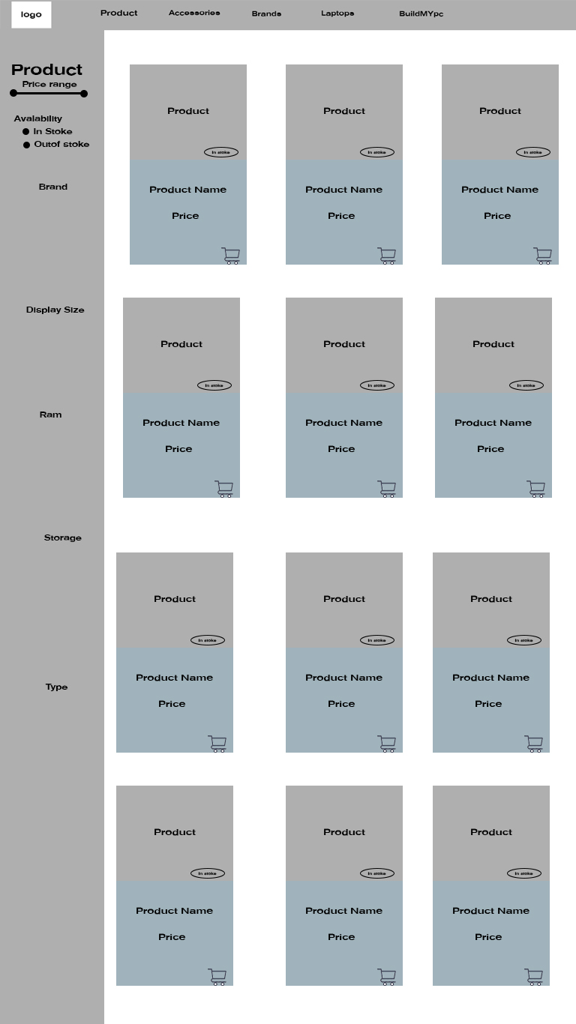

Product Listing Page

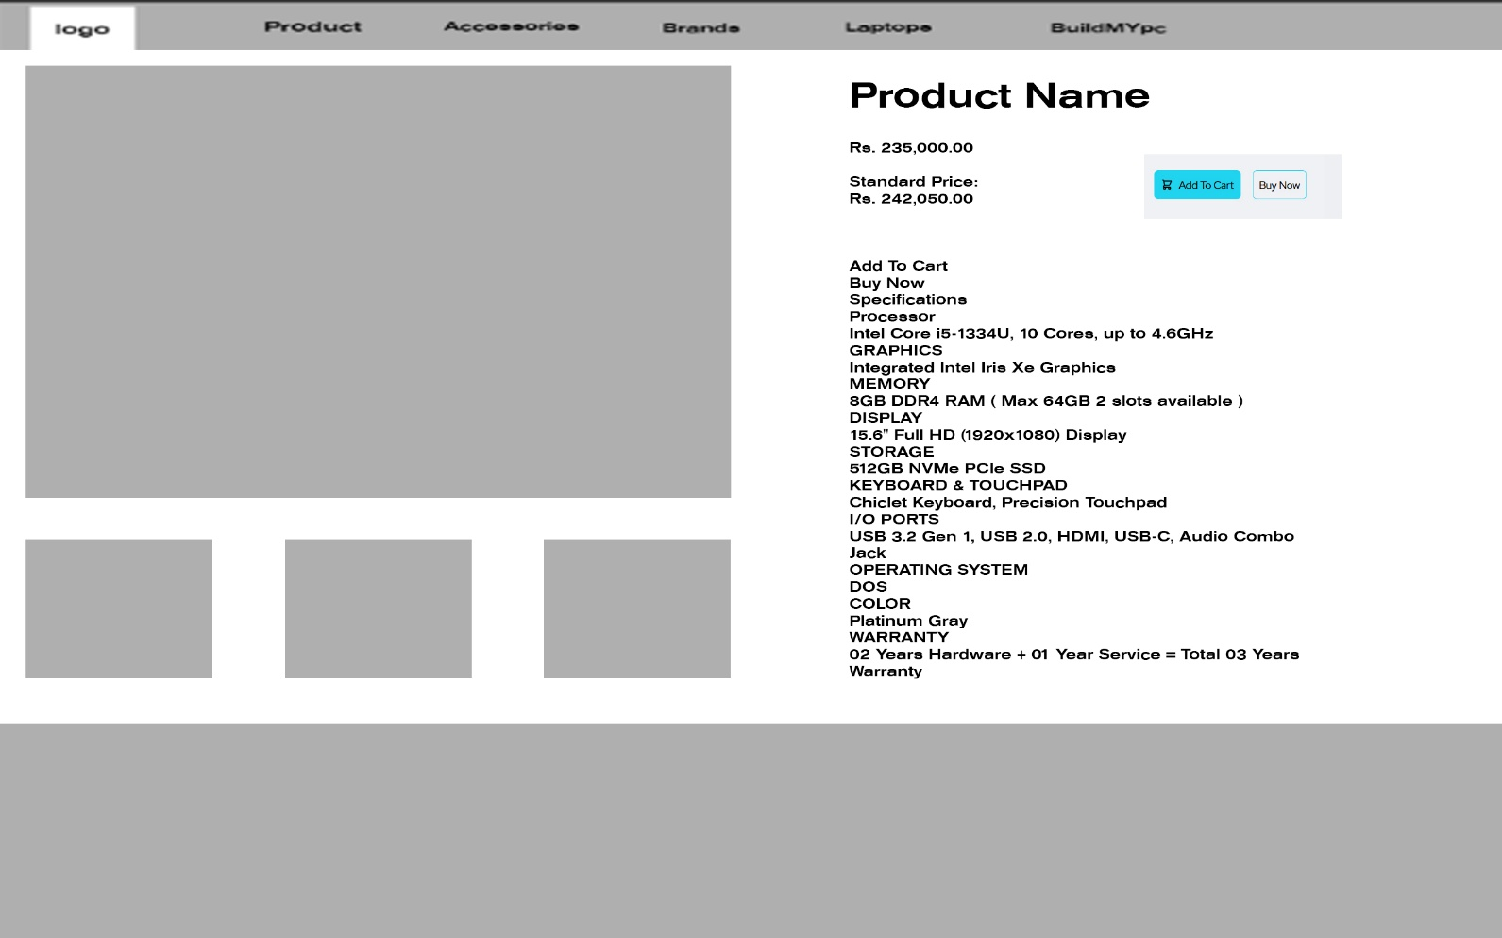

Add to cart and Checkout Page

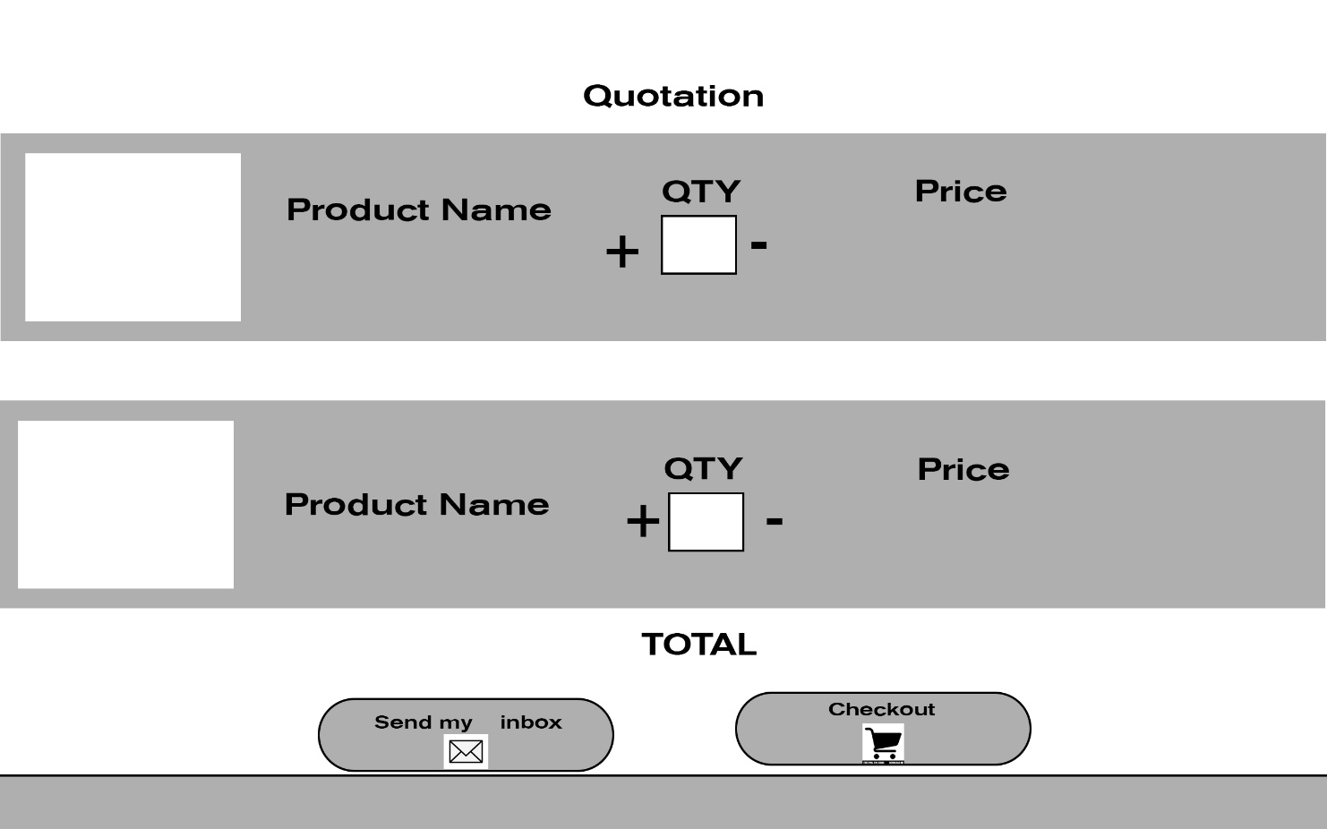

2. Entity Relationship (ER) Diagram
PcPoint uses MongoDB, a NoSQL document database. Even so, the collections below are designed with clear logical relationships between entities (similar to a relational schema) to keep the data consistent and easy to query.
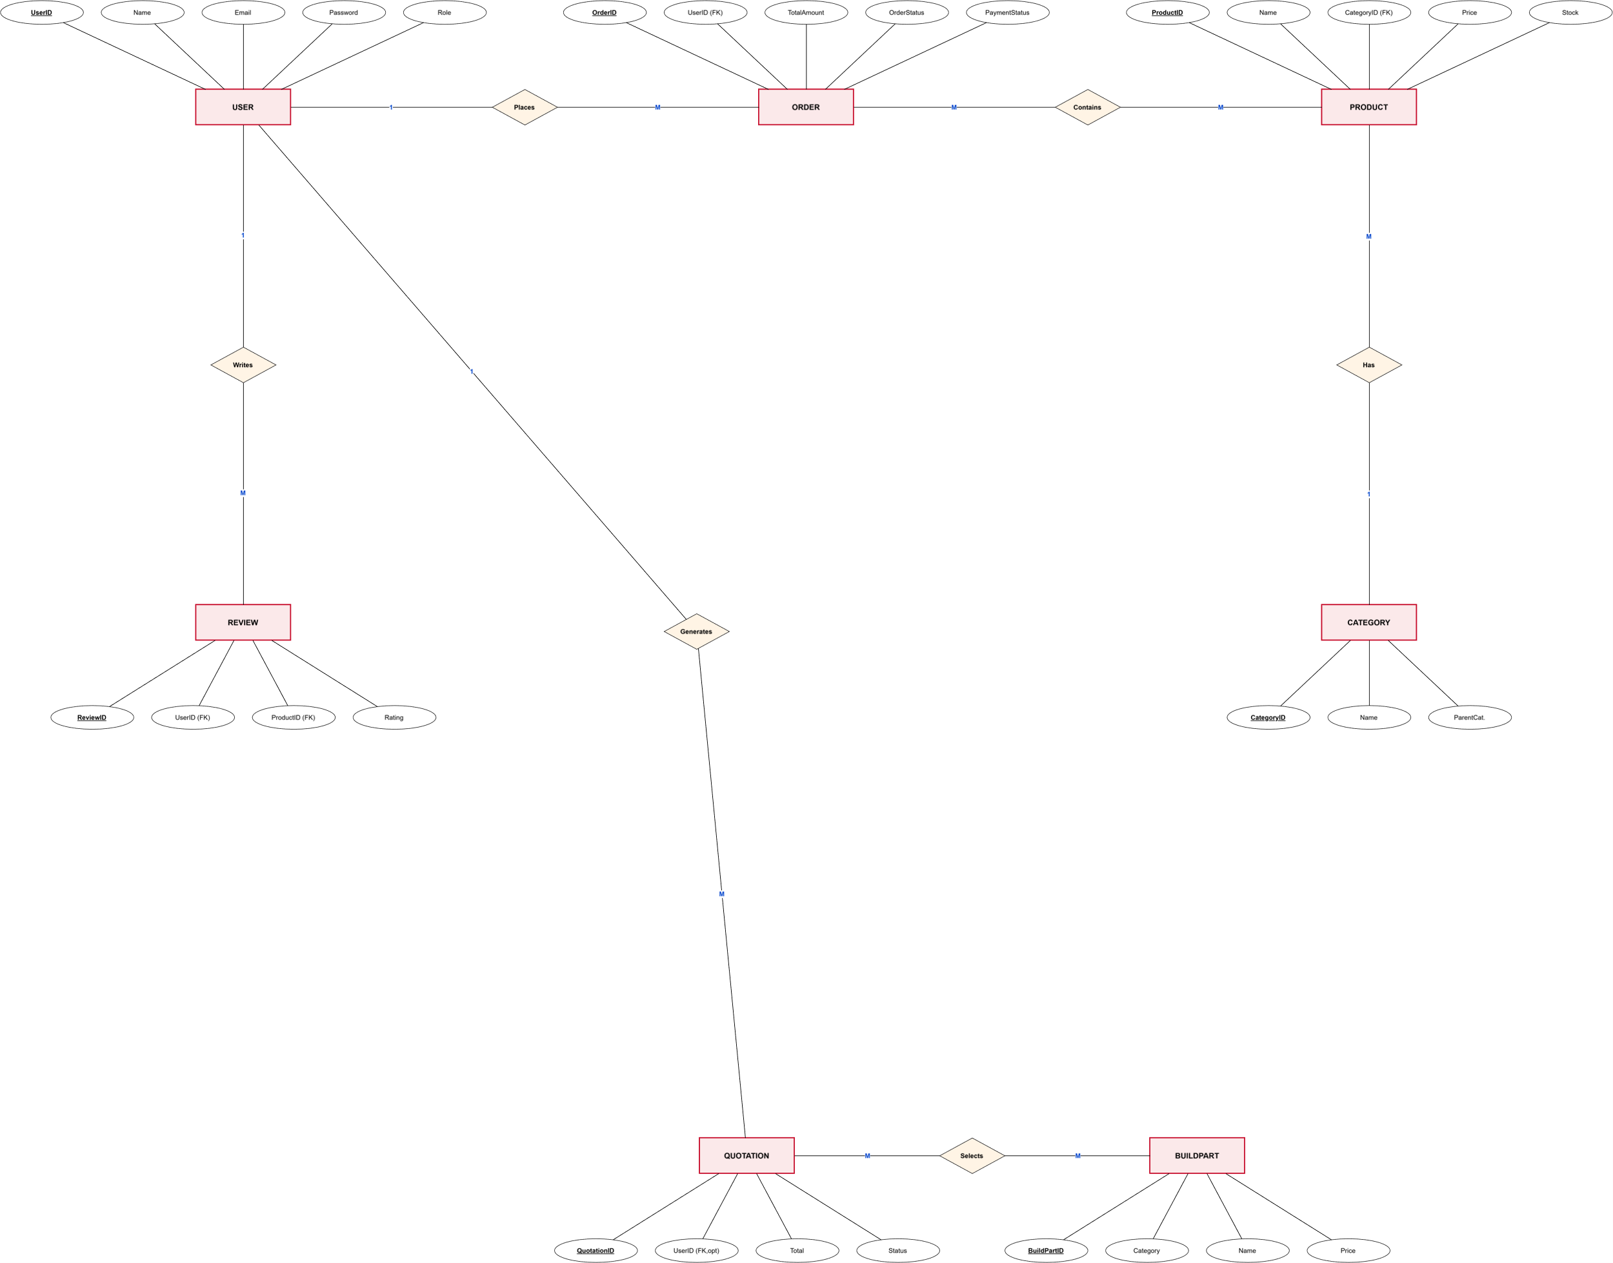

User (1) — Order (M): one user can place many orders
- User (1) — Review (M): one user can write many reviews
- User (1) — Quotation (M): one user can generate many build quotations (guests can also generate quotations without a user link)
- Category (1) — Product (M): one category contains many products
- Product (1) — Review (M): one product can have many reviews
- Order (M) — Product (M): an order contains many products, and a product can appear in many orders (linked through the order's items array)
- BuildPart (1) — Quotation Item (M): one build part (e.g. a specific GPU) can appear as a line item in many quotations
3. List of Tables and Attributes
PcPoint's MongoDB database is organised into the following collections (tables). Each is listed below with its attributes, data type, and a short description.
3.1 Users — stores customer and admin accounts
Attribute | Data Type | Description
UserID (_id) | ObjectId | Primary key, auto-generated unique identifier
Name | String | Full name of the user
Email | String | Unique login email address
Password | String (hashed) | Password, stored as a bcrypt hash — never in plain text
Phone | String | Contact phone number
Address | String | Delivery / billing address
Role | String | Account type — "customer" or "admin"
CreatedAt | Date | Date and time the account was created
3.2 Products — stores every item sold on PcPoint
Attribute | Data Type | Description
ProductID (_id) | ObjectId | Primary key, auto-generated unique identifier
Title | String | Product name
Description | String | Full product description
Price | Number | Selling price (LKR)
DiscountPrice | Number | Discounted price, if on offer (optional)
StockQuantity | Number | Units currently in stock
ImageURL | Array<String> | One or more product image URLs
CategoryID | ObjectId (FK) | Reference to the Categories collection
Specs | Array | Key–value specification pairs (e.g. RAM: 16GB)
Rating | Number | Average customer rating (1–5)
CreatedAt | Date | Date the product was added
3.3 Orders — stores customer purchases
Attribute | Data Type | Description
OrderID (_id) | ObjectId | Primary key, auto-generated unique identifier
UserID | ObjectId (FK) | Reference to the Users collection (who placed the order)
ProductsList (items) | Array | List of {ProductID, quantity, price} for this order
ShippingAddress | String | Delivery address for this order
PaymentMethod | String | Card / PayHere / Cash on Delivery / Bank Transfer
PaymentStatus | String | Paid / Pending / Failed
TotalAmount | Number | Total order value (LKR)
OrderStatus | String | Pending / Processing / Shipped / Delivered
CreatedAt | Date | Date and time the order was placed
3.4 Categories — product category tree
Attribute | Data Type | Description
CategoryID (_id) | ObjectId | Primary key, auto-generated unique identifier
Name | String | Category name (e.g. "Graphics Cards")
Slug | String | URL-friendly identifier
ParentCategory | ObjectId (FK, optional) | Reference to a parent category, for subcategories
3.5 Reviews — customer product reviews and ratings
Attribute | Data Type | Description
ReviewID (_id) | ObjectId | Primary key, auto-generated unique identifier
UserID | ObjectId (FK) | Reference to the Users collection (review author)
ProductID | ObjectId (FK) | Reference to the Products collection
Rating | Number | Star rating given (1–5)
Comment | String | Written review text
CreatedAt | Date | Date the review was posted
3.6 BuildParts — catalogue of selectable PC-build components
Attribute | Data Type | Description
BuildPartID (_id) | ObjectId | Primary key, auto-generated unique identifier
Category | String | Part category (CPU, RAM, GPU, PSU, etc.)
Name | String | Component name/model
Price | Number | Price (LKR)
Image | String | Image URL/icon reference
InStock | Boolean | Whether the part is currently available
3.7 Quotations — PC-build price quotations generated for customers
Attribute | Data Type | Description
QuotationID (_id) | ObjectId | Primary key, auto-generated unique identifier
QuoteNumber | String | Human-readable quote reference, e.g. PP-20260822-1234
UserID | ObjectId (FK, optional) | Reference to the Users collection, if logged in
Items | Array | List of {BuildPartID, quantity} selected for the build
Subtotal | Number | Sum of all line items (LKR)
DeliveryFee | Number | Flat delivery charge (LKR)
Total | Number | Subtotal + delivery fee (LKR)
Status | String | Draft / Sent / Accepted / Expired
CreatedAt | Date | Date the quotation was generated

4. GitHub Repository — Version Control
A GitHub repository was created for PcPoint to track code changes and back up work throughout development. Screenshots of the repository are provided below as evidence.
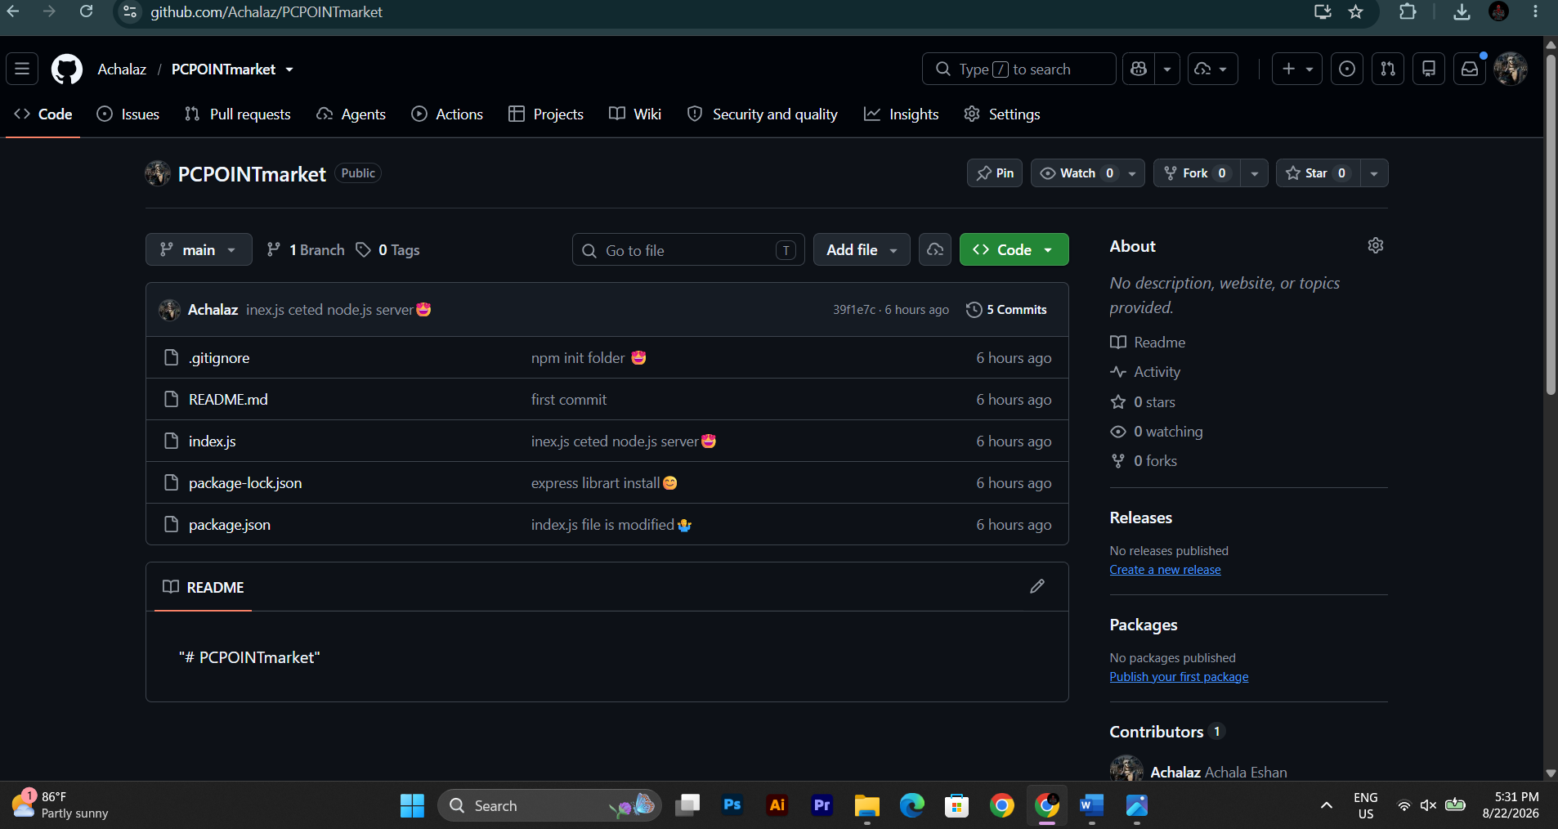

https://github.com/Achalaz/PCPOINTmarket
GITHUB Repository Link

